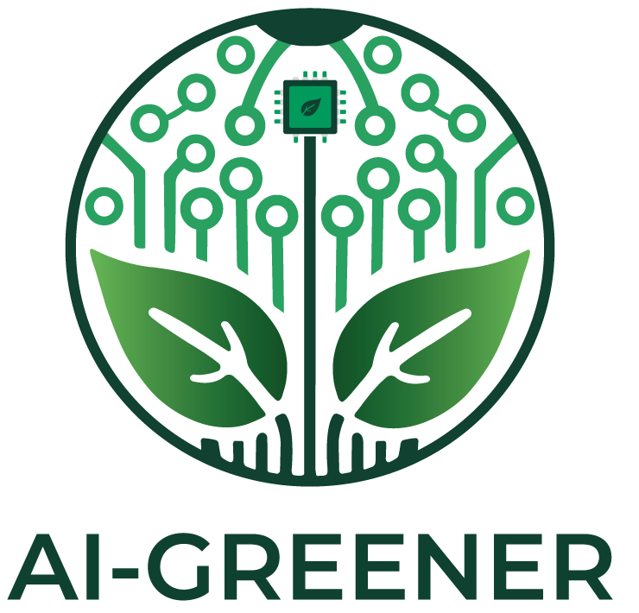
2024-1-AT01-KA220-SCH-000248327

LESSON PLAN

Designing sustainable solutions with AI

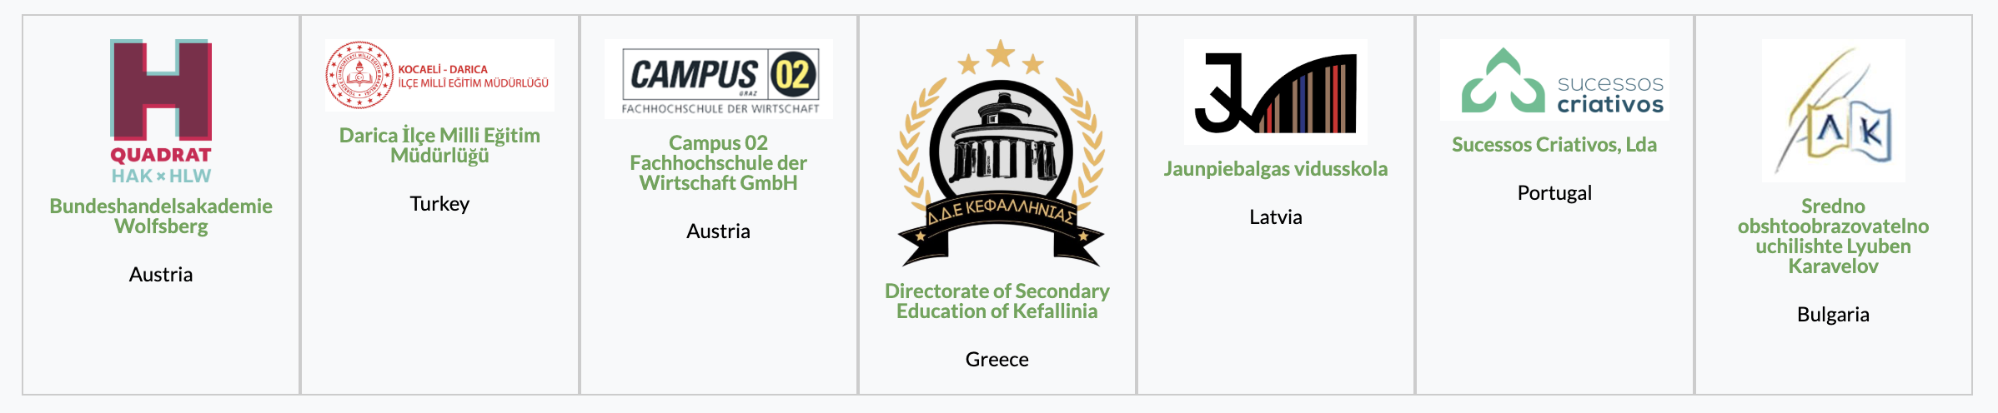

Authors
Organization Name + Logo
Individuals who contribute

Jaunpiebalgas Vidusskola | 
Kārlis Krastiņš
Indriķis Andris Birznieks

Disclamer


Funded by the European Union. Views and opinions expressed are however those of the author(s) only and do not necessarily reflect those of the European Union or the European Education and Culture Executive Agency (EACEA). Neither the European Union nor EACEA can be held responsible for them.



TITLE
AI for green entrepreneurship: Designing sustainable solutions with AI

GRADE LEVEL
- ISCED Level 3 – Upper Secondary Education (ages 15–18)

SUBJECT AREA
- Environmental Studies
- Economics
- Computer Science
- Technology and Design
- Social Studies

TYPE
- Project

DURATION
- Double session (2 × 60 minutes) optional project-based homework.

LEARNING OBJECTIVES
O1 – Explain how AI can contribute to environmental sustainability and support the achievement of sustainable development goals.
O2 - Analyze real-world examples of AI applications that reduce environmental impact in sectors such as energy, transportation, agriculture, and waste management.
O3 - Design a green business idea that incorporates AI to address an environmental challenge.
O4 - Present and justify a sustainable entrepreneurship proposal using environmental, social, and economic arguments.

Key Competences Developed
- Literacy
- Mathematical competence and competence in STEM
- Digital competence
- Personal, social and learning to learn competence
- Citizenship competence
- Entrepreneurship competence
- Cultural awareness and expression competence

Prior Knowledge / Prerequisites

-) Basic understanding of environmental sustainability and climate changes.

-) Basic digital literacy and internet research skills.

-) Basic knowledge of entrepreneurship concepts (problem, solution, customer, value proposition).

Lesson/Project Outline

Phase 1 – Introduction (Engage & Contextualize)

Teacher presents the question: Can AI help save the planet?

Students participate in a short brainstorming activity identifying environmental challenges such as: climate change, energy waste, food waste, pollution, deforestation.

Teacher introduces students on topics:
What is AI?
How AI is already used in sustainability initiatives?
Examples of AI – powered environmental solutions.

Expected outputs: Class discussion notes, list of environmental challenges suitable for AI solutions.

Phase 2 – Exploration (Investigate & Compare)

Students split into small teams to analyze specific global case studies where machine learning algorithms mitigate resource depletion (e.g., smart precision farming or AI-driven grid balancing).
Teams map out the exact inputs, computational logic, and ecological advantages realized by their assigned case study.
Expected Outputs: A structured Matrix analysis comparing conventional ecological strategies versus enhanced AI-driven methodologies.

Phase 3 – Application (Hands-On Practice)

Students adopt the role of sustainable tech entrepreneurs to conceptualize a novel AI venture addressing one of the core challenges highlighted in Phase 1.

Teams complete a specialized "Green AI Business Model Canvas" emphasizing carbon footprint reduction, technical feasibility, and customer monetization pathways.

Expected Outputs: A drafted Green AI Ideation Canvas and an accompanying 3-minute pitch outline.

Phase 4 – Reflection & Consolidation (Present & Connect)

Teams pitch their completed Green AI venture to the class in a structured "Eco-Shark Tank" format.

Peers critique proposals from a sustainability and viability perspective, followed by a general reflection on the ethical implications of run-time data centers vs. environmental offsets.

Expected Outputs: Pitch presentations, peer review evaluation records, and individual self-reflection logs.

Assessment Criteria

Evaluations are continuously measured against learning objectives to verify theoretical execution and interactive design proficiency.

Teaching Materials
Peer review feedback sheet.

Self-assessment sheet.

External Resources and References
Resource (name) | Link (external or to the folder on Teams)
Climate Change AI Research & Community Hub  UN Sustainable Development Goals Knowledge Platform | https://www.climatechange.ai/  https://sdgs.un.org/goals

